**PRACTICAL: 01**

**AIM:**

* MATLAB Introduction and Environment study.
* To study Image processing tools in MATLAB.
* List out the MATLAB Commands which are used in Image processing.

**OBJECTIVES:**

* Student will be able to understand image processing toolbox of MATLAB software and they will familiar with GUI of the software.
* Student will be learned various MATLAB commands which can be used to handle the image in MATLAB software.
* Student will be learned syntax and purpose of the MATLAB commands.

**STUDENT REPORT:**

* **Introduction**
* MATLAB stands for Matrix Laboratory.
* MATLAB has many functions and toolboxes
  + Integration
  + Image Processing
  + Linear Algebra
  + Etc..
* Solves computing problems in a fraction of the time.
* 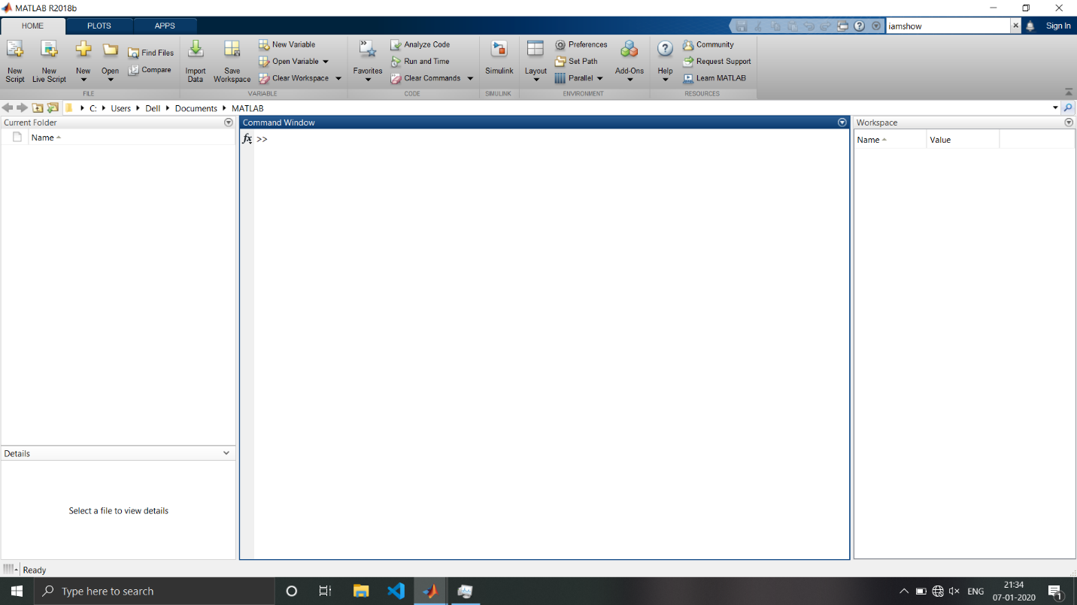**GUI Environment**
* Command Window
  + The Command Window enables you to enter individual statements at the command line and view the generated results.
* Current Folder
  + The Current Folder browser enables you to interactively manage files and folders in MATLAB. Use the Current Folder browser to view, create, open, move, and rename files and folders in the current folder.
* Workspace
  + The Workspace browser enables you to view and interactively manage the contents of the workspace in MATLAB. For each variable or object in the workspace, the Workspace browser also can display statistics, when relevant, such as the minimum, maximum, and mean.
* **Commands**
* Imread()
  + imread([filename](https://localhost:31515/static/help/matlab/ref/imread.html?searchHighlight=imread&searchResultIndex=1#mw_abb56802-ede7-4bfd-a64e-0743144c1db9)) reads the image from the file specified by filename, inferring the format of the file from its contents. If filename is a multi-image file, then imread reads the first image in the file.
* Imwrite()
  + imwrite([A](https://localhost:31515/static/help/matlab/ref/imwrite.html?searchHighlight=imwrite&searchResultIndex=1" \l "btv3cny-1-A),[filename](https://localhost:31515/static/help/matlab/ref/imwrite.html?searchHighlight=imwrite&searchResultIndex=1#btv3cny-1-filename)) writes image data A to the file specified by filename, inferring the file format from the extension. Imwrite creates the new file in your current folder. The bit depth of the output image depends on the data type of A and the file format.
* Imshow()
  + imshow([I](https://localhost:31515/static/help/matlab/ref/imshow.html?searchHighlight=imshow&searchResultIndex=1#bvmnrxi-1-I)) displays the grayscale image I in a figure. imshow optimizes figure, axes, and image object properties for image display.
* rgb2gray()
  + The rgb2gray function converts RGB images to grayscale by eliminating the hue and saturation information while retaining the luminance.
* Imhist()
  + imhist([I](https://localhost:31515/static/help/images/ref/imhist.html?searchHighlight=imhist&searchResultIndex=1#buo3qek-1-I)) calculates the histogram for the grayscale image I. The imhist function returns the histogram counts in counts and the bin locations in binLocations. The number of bins in the histogram is determined by the image type.
* Imfinfo()
  + imfinfo([filename](https://localhost:31515/static/help/matlab/ref/imfinfo.html?searchHighlight=imfinfo&searchResultIndex=1#mw_6b875775-4a4d-4a8d-b882-bc79f913e2e2)) returns a structure whose fields contain information about an image in a graphics file, filename.
* Imbinarize()
  + imbinarize([I](https://localhost:31515/static/help/images/ref/imbinarize.html#bu1w0rc-1-I)) creates a binary image from 2-D or 3-D grayscale image I by replacing all values above a globally determined threshold with ‘1’ and setting all other values to 0’s.

**OUTCOME:**

1. Installation of MATLAB Software and understanding of GUI environment
2. Learning of image processing commands and functions
3. Understanding of MATLAB workspace and interpretation of digital image concepts

**EVALUATION RUBRICS:**

|  |  |  |  |  |  |
| --- | --- | --- | --- | --- | --- |
| **Outcome achieved** | **Max. Marks** | **Inadequate**  **(0%)** | **Good**  **(50%)** | **Excellent**  **(100%)** | **Marks Obtained** |
| 1 | 2 |  |  |  |  |
| 2 | 4 |  |  |  |  |
| 3 | 4 |  |  |  |  |
|  | 10 |  | | |  |

Date: ______________ Signature of Evaluator: ___________________